**Calculator task:**

Original code:

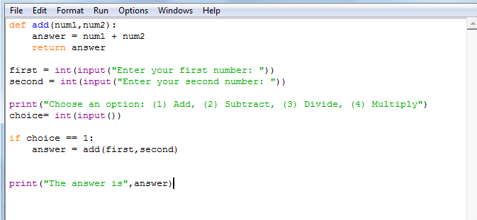

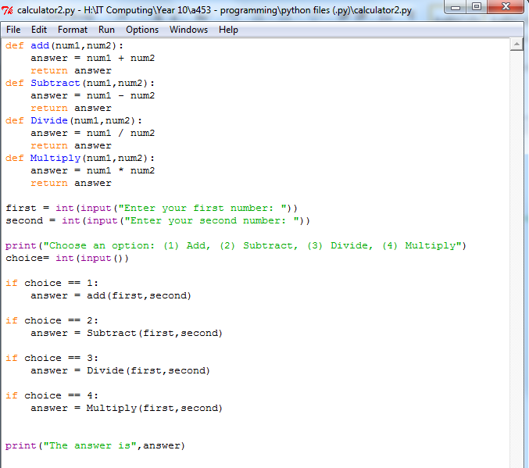My code:

I have created new def function for the variables add, subtract, divide and multiply. I have also created a if statements for each.